10-19-12

Unlearning4 in II Category Learning Preliminary Results

Overview

This is an extension of Unlearning 1 which is Experiment 2 in the JEP:General paper. In that study we had 300 acquisition and 300 reacquisition trials with veridical feedback. However during the intervention phase (in the original summaries we called this extinction) there is a 75% chance of random feedback and a 25% chance of correct feedback.

What we want to do now is introduce a dual task during different stages of the session and for different durations. This is the same dual task that we used in dual task/aggregate feedback study.

The figure below (thanks to Matt) says it all. I do have a few comments.

1. Notice that we are changing from 300 acquisition-300 intervention-300 reacquisition to 300 acquisition-400 intervention-150 reacquisition.
2. We will need some general instructions at the start of the study giving them an overview of the whole task. Then we will need instructions once the dual task is introduced, and a final brief set of instructions telling them that the “no dual task” conditions are back. Cage—go ahead and generate some instructions for each phase using what you already have and your dual-aggregate feedback instructions then run them by me.
3. “random learning” below is the same as unlearning.

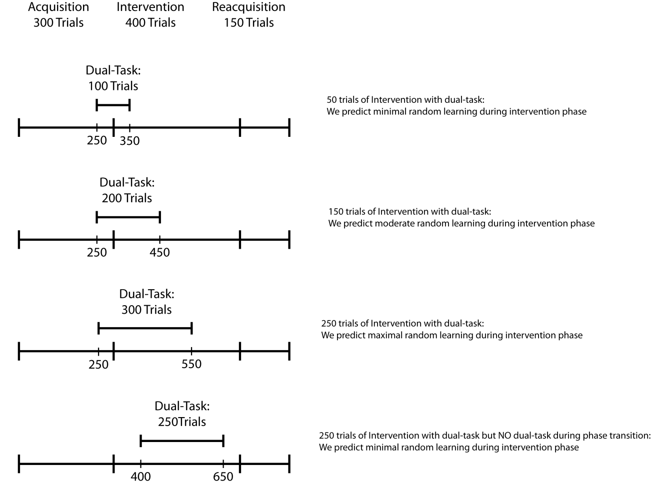

As far as timing on each trial I assume that you used something like the following:

No dual task trials: Stim (resp term) – 1000ms feedback – 500ms iti

Dual task trials: Stim (resp term) – 1000ms feedback – value/size query (resp term) – response – 1000ms feedback – 500ms iti

For lack of better terminology we will call these conditions 1 – 4 from top to bottom of the figure above.

We also need a control condition that has NO dual task trials.

As far as file names lets go with unl41x.dat, unl42x.dat, unl43x.dat and unl44x.dat where unl4 denotes unlearning experiment 4 and the x is the subject number. We will also have unl4cx.dat for the control condition.

Same format at unlearning 1 but add columns for dual task

Let’s start with 10 in each of these 5 conditions.

Extra notes on the dual task:

1. During stimulus 1 presentation in the dual task condition, the stroop stimuli are displayed concurrently to the left and right of the categorization stimulus for 200 ms and are then replaced by a rectangular white mask (one on each side) for 200ms.
2. On 85% of trials the numerically larger number is physically smaller.
3. During the value/size query, on half of the trials the word “value” comes up and on half of the trials the word “size” comes up. This queries the participant to determine which side (left or right) had the numerically or physically larger stimulus.
4. The participant is instructed to perform the numerical task without error and to use whatever is left over to do the categorization task.
5. Participants’ current accuracy on the numerical Stroop task should be indicated at the top of the screen when they received feedback regarding their performance on the concurrent task on each trial. Their percentage correct score should be listed in green if it was above 80% and red if it was below 80%.

Preliminary findings

The conditions above are numbered 1 – 4 from the top to bottom. We have 9 or 10 subs in each condition. I am going to plot only in 25-trial blocks. We have some folks who are doing really well at the dual task throughout, some who are good for some blocks but not others and some who are poor throughout.

So first I need some advice on exclusion criteria to use for the dual task.

I also need advice on initial acquisition exclusions. Given that the earliest that the dual task is presented is in block 250, I suggest that we drop anyone who is below 40% during trials 200-250.

The plots below do not exclude anyone. Remember that they are also based on only 9 or 10 per condition. Give these a look and give me your thoughts

Accuracy data



Stroop accuracy data